**Provide a summary of the main concepts that went through about solar radiation (formulas are not needed)**

**Solar radition:**

Solar radiation refers to the fact that the sun transmits energy in the form of electromagnetic waves. It refers to the electromagnetic waves and particle flows emitted by the sun into space. The energy transmitted by solar radiation is called solar radiant energy.  
Solar radiation intensity refers to the intensity of solar radiation reaching the ground. The absorption, reflection, and scattering of the sun's radiation by the atmosphere greatly weaken the solar radiation reaching the ground.

**Diffuse and direct beam solar radiation:**

Direct solar radiation is radiation that the sun directly projects into the ground in the form of parallel rays.

Diffuse radiation refers to the amount of solar radiation emitted in all directions except the direction of the sun, also known as sky radiation and scattered radiation. It is caused by the scattering of solar radiation by suspended particles in the atmosphere, and the reflection of solar radiation by the ocean, land and buildings on the surface of the earth.

**Atmospheric absorption：**

Atmospheric absorption refers to the absorption of various components in the atmosphere when electromagnetic waves propagate therein.

Most solar ultraviolet radiation is absorbed by oxygen and nitrogen in the stratospheric ozone  
In the infrared range, the main absorption gases are water vapor, carbon dioxide and ozone. In the microwave range, the main absorption component is oxygen (and water vapor).

**Air mass：**

The extent to which the atmosphere affects the surface of the Earth receiving sunlight is defined as air quality. The state in which the mass of the atmosphere is zero (AM 0) refers to the case where sunlight is received in the extraterrestrial space, and is suitable for applications such as satellites and spacecraft. The state in which the air mass is 1 (AM 1) refers to the case where the sunlight directly illuminates the surface of the earth vertically, and the incident optical power is 925 W/m2. The radiant intensity of sunlight in the free space at its average distance to the Earth is defined as the solar constant, which is 1367 W/m2.

**Solar energy: availability**

The solar radiation, available on the Earth’s surface for conversion in other energy forms, depends on the sun position in the sky, the weather condition, the site altitude over the sea level, and the sunshine hours.

1. Click the “Weather File” to add the weather data of Piacenza in OpenOffice.

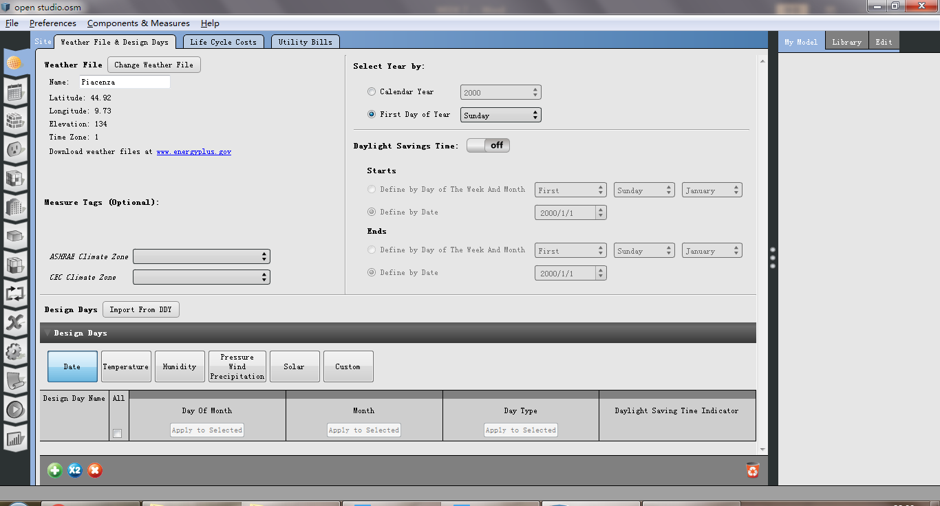

2. Click the “construction”, start customize the building, renaming it.

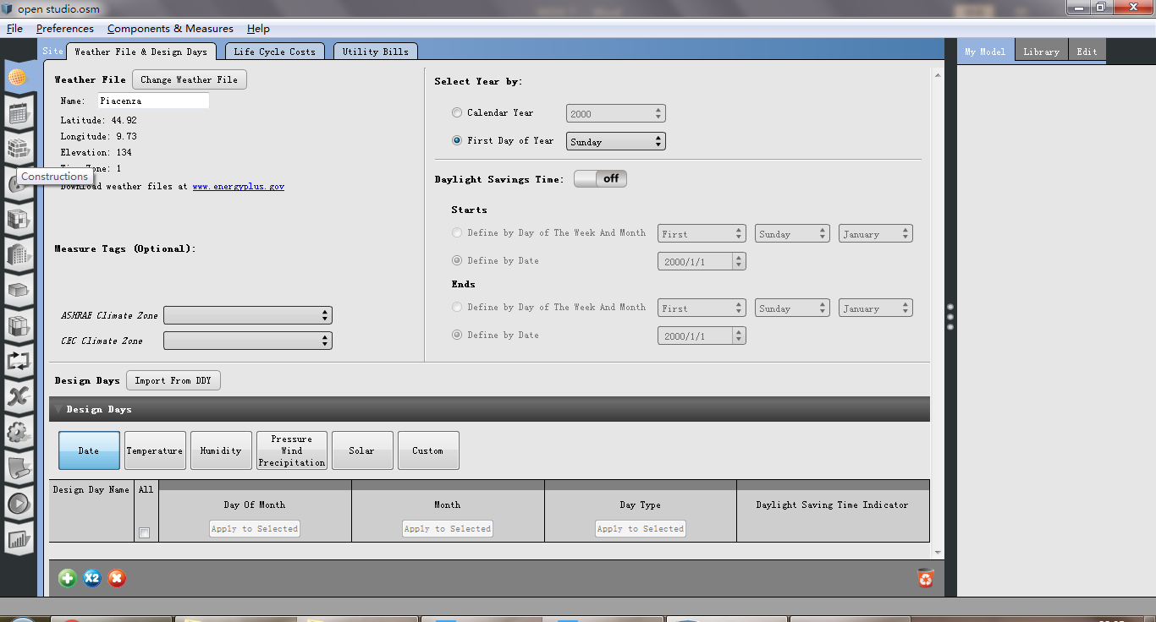

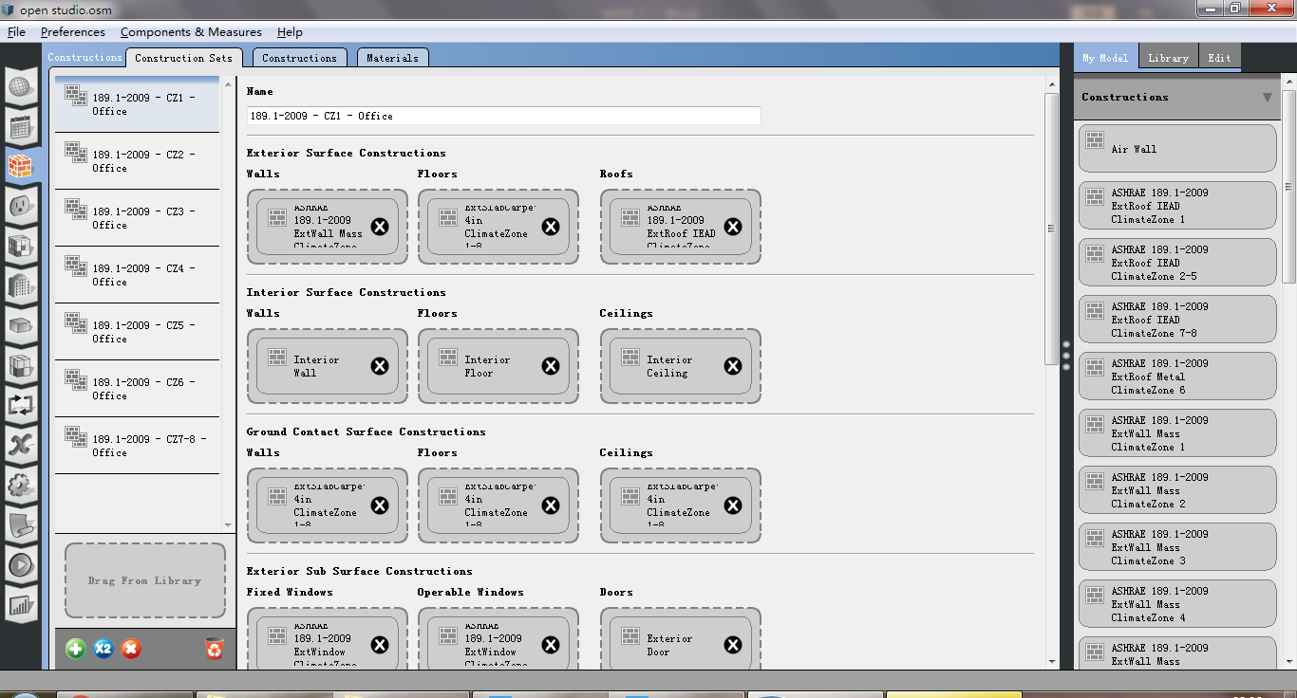

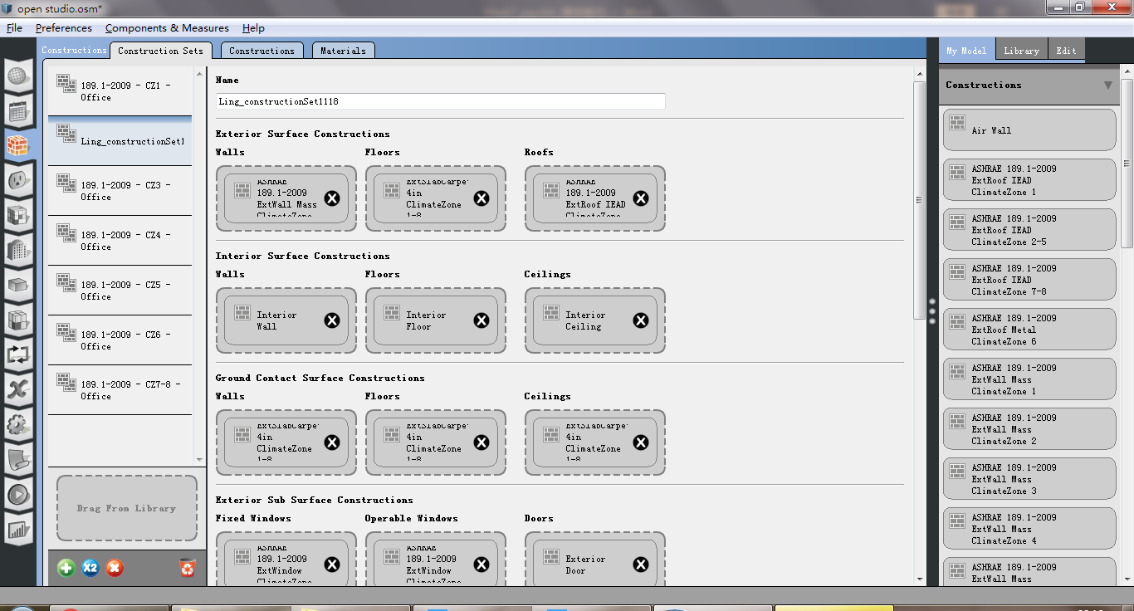

3. Click “construction” to add a new project and startcustomizing the wall package in the “construction sets” window.

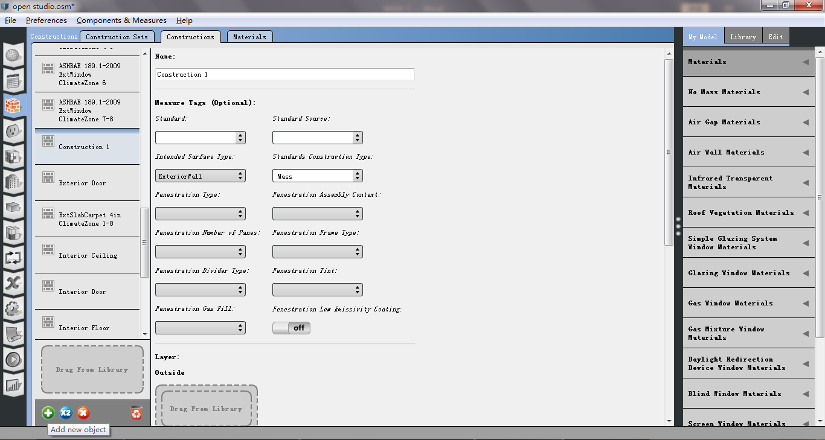

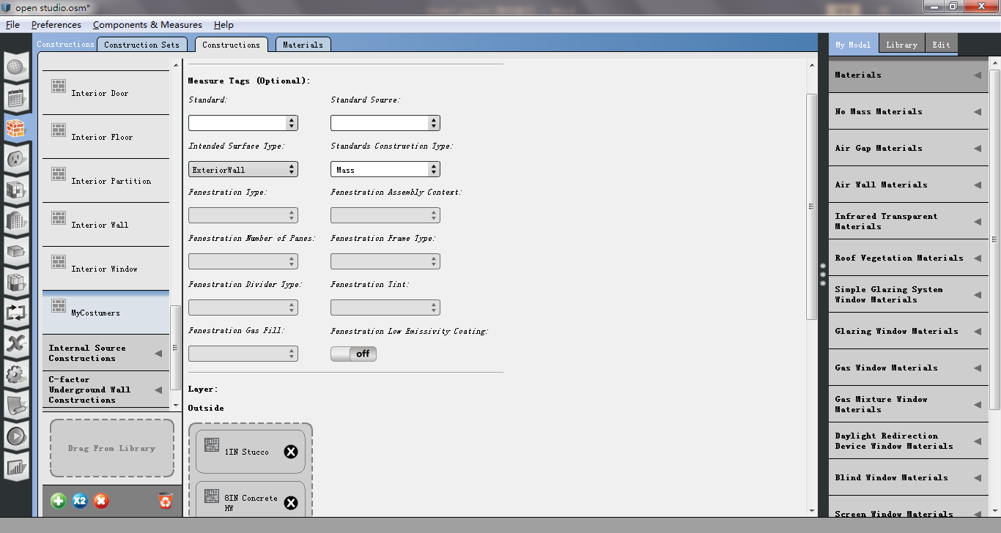

4. Click “Material” to add a new material and decide the type of wall insulation and insert it later in the package.

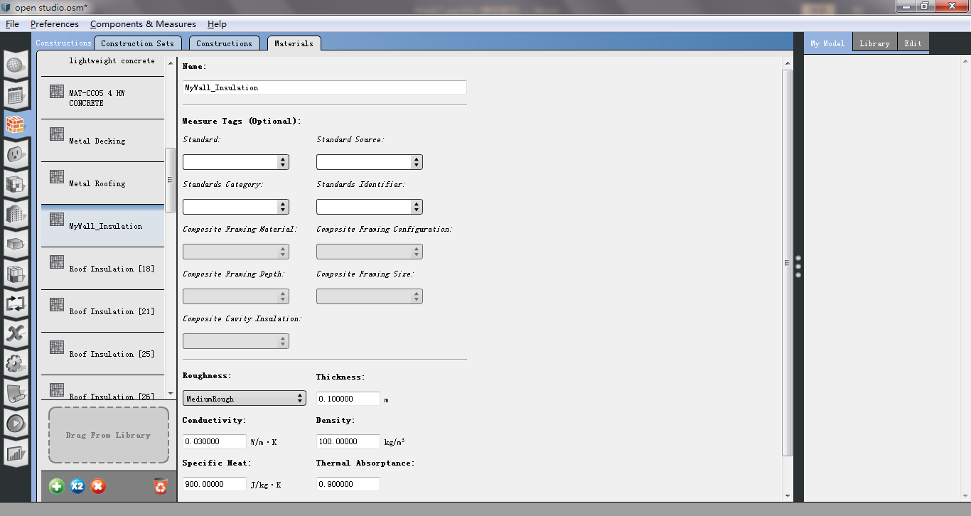

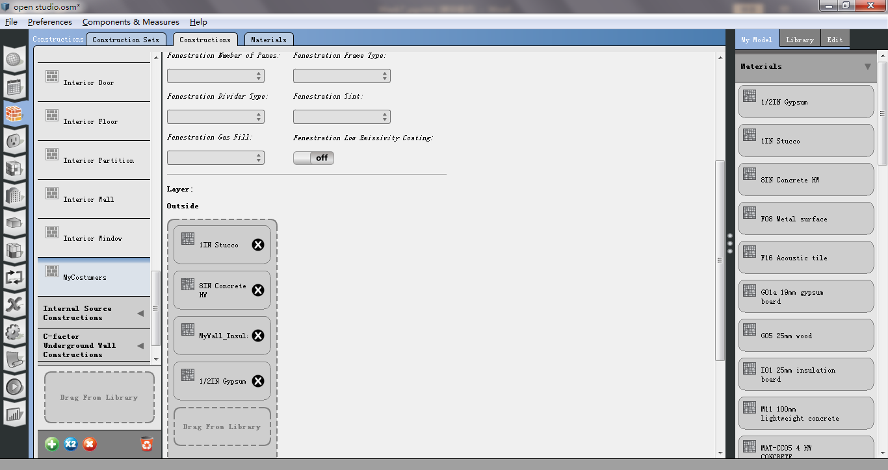

5. Insert the wall in the building data.

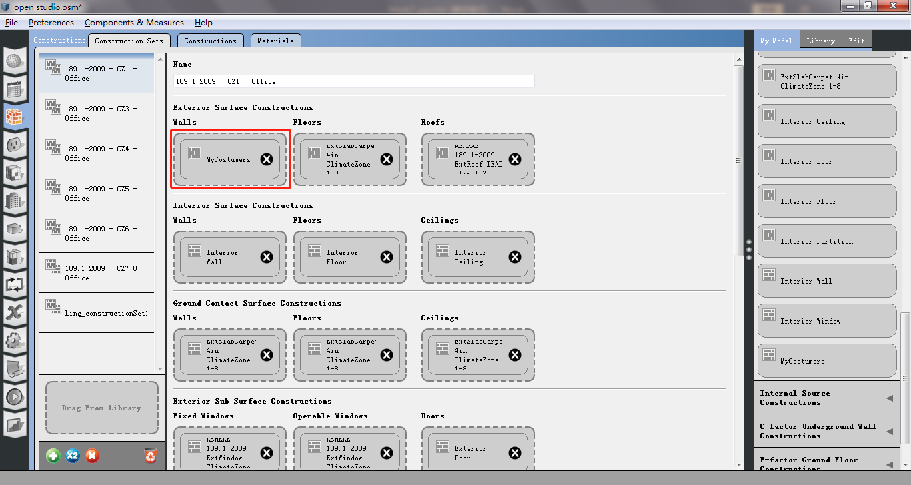

6. Click “space” window and insert the project layer with our modifications applying it to the whole building.

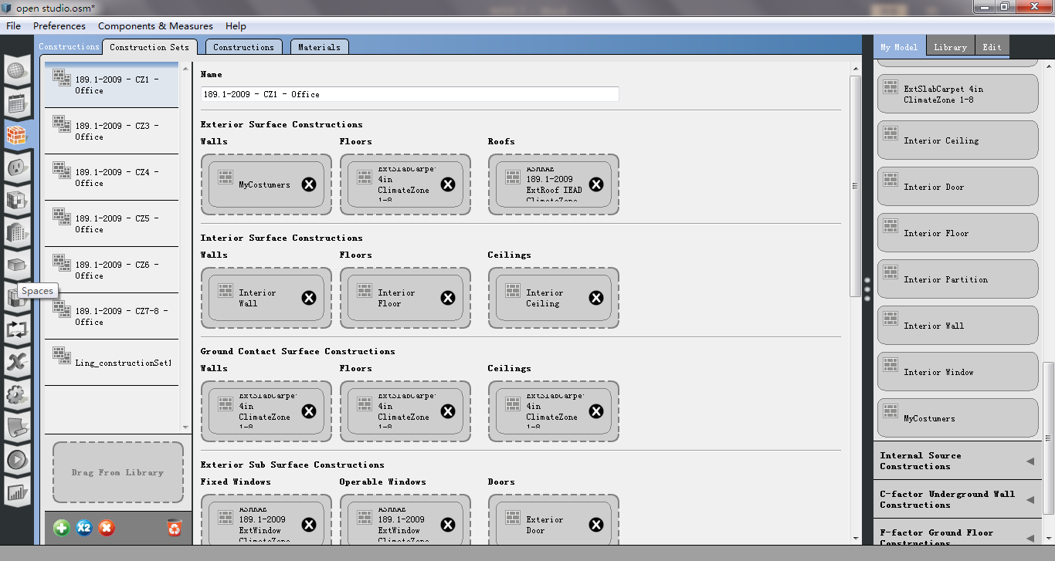

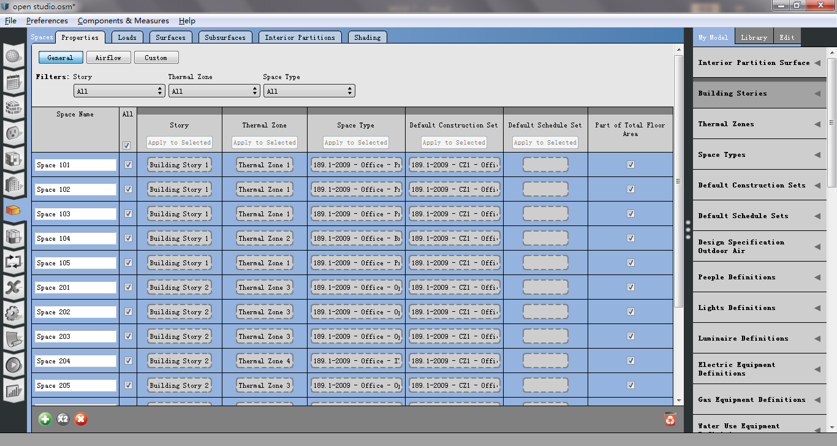

7. Return to “schedule sets” to enter all the information relating to activities, equipments, etc and their schedules.

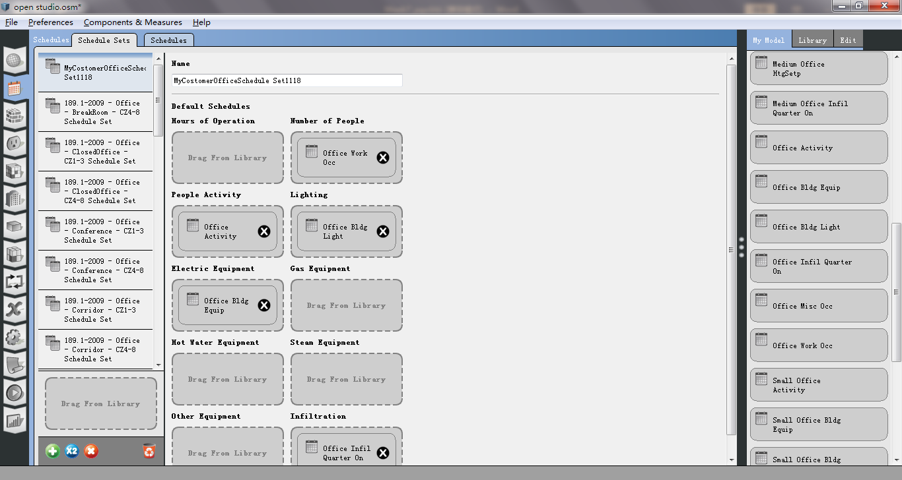

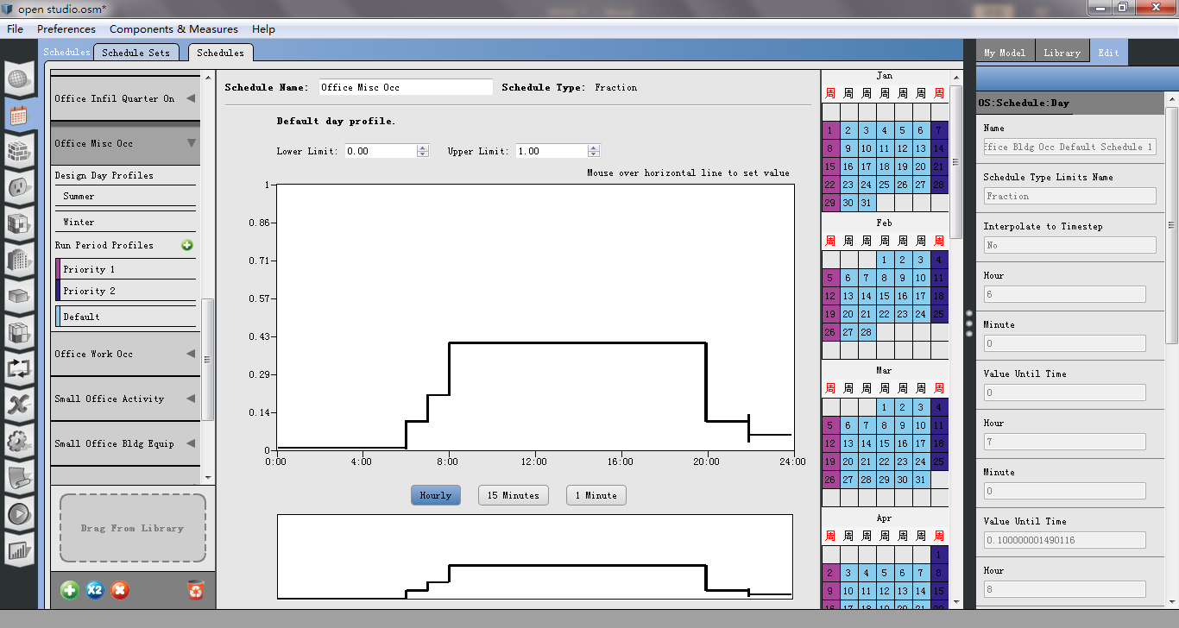

8. Click the “loads” command to change other specifications, like people, light,electricity, etc.

